COMPUTER SYSTEM

- PARTS:

QUANTITY: PART #: NOMENCLATURE: LENGTH:

1 PER MACHINE 18678-1 CONTROL, SERVO MOTOR, N/A

1 PER MACHINE 18703- BOARD, DIGITAL I/O, 24CH N/A

1 PER MACHINE 18684- FRAMEGRABBER, PC BASED N/A

2 PER MACHINE 16247- NETWORK, RESISTOR N/A

- SETUP:

- SET THE BASE ADDRESS OF JUMPER W2, OF THE SERVO MOTOR CONTROLLER (MODEL 5650A, TECHNOLOGY 80), TO 310 HEX, ACCORDING TO DIAGRAM 1.

- ENSURE THAT THERE IS A JUMPER AT RP17 ON THE SERVO MOTOR CONTROLLER.

- REMOVE ANY JUMPERS, ON THE SERVO MOTOR CONTROLLER, AT TP1, TP2, W3, W4, AND W5.

- REMOVE JUMPER W3, OF THE SERVO MOTOR CONTROLLER, TO SET THE DRIVE ENABLE SIGNAL POLARITY TO HIGH.

- REMOVE JUMPERS J3 AND W3, OF THE VIDEO FRAMEGRABBER BOARD (DT55 / DATA TRANSLATION).

- SHORT JUMPERS W15, W9, W8, W6, W2, AND W5, OF THE VIDEO FRAMEGRABBER BOARD.

- SET THE BASE ADDRESS, OF THE DIO INTERFACE BOARD (CIO-DIO24 / CTR3), TO 300 HEX, ACCORDING TO DIAGRAM 2.

- INSTALL AND SOLDER THE TWO RESISTOR NETWORKS INTO PORT A AND PORT B WITH PIN #1 TO THE RIGHT-SIDE (LOW), PIN #10 TO THE LEFT-SIDE (HIGH).

- SET THE IR1, OF THE DIO INTERFACE BOARD, TO X.

- SET THE WAIT STATE, OF THE DIO INTERFACE BOARD, TO ON.

- ASSEMBLY:

- REMOVE THE COVER FROM THE COMPUTER CHASSIS.

- REMOVE THE MOUNTING BAR FROM THE COMPUTER.

- INSTALL THE BOARDS, ACCORDING TO DIAGRAM 3.

- MAINTAIN A ONE SPACE IN BETWEEN THE MOTHERBOARD AND THE FRAMEGRABBER BOARD.



DIAGRAM 1

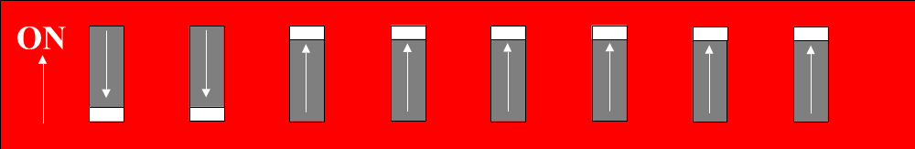

DIAGRAM 2

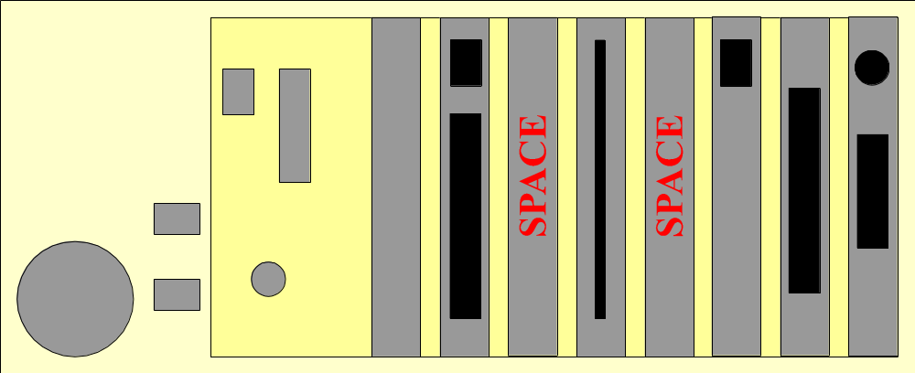

DIAGRAM 3

